Editor - Design Doc

**Status:** Under review

**Created:** Nov 03, 2022

**Last Updated:** Nov 08, 2022

**Authors:** Tal Ben-Zur

**Additional Links**: [[Shared Doc req.pdf](https://drive.google.com/file/d/1fKQkn8He63isOvf0L3mgw0ppgdt_lz3o/view?usp=sharing), [Shared Documents - Design Doc](https://docs.google.com/document/d/1jd7uOGuQKWG18D8QNcbV64q2N91EqW6Y15Lc7c1MT7U/edit?resourcekey=0-41sj9qgW3AKXqmAXce7MQA#)]

# Background

As described in the application design document, the purpose of the system is to allow users to create files, edit them with collaborators and manage viewing / editing permissions.

Editing permissions will allow the user to edit content from the page.

More documentation:

* [REQUIREMENTS f4:Editor](https://docs.google.com/spreadsheets/d/1XtuKYG03LFO5us4CK2ROIxx7L9JoDqVnpBYjWTjxxns/edit?usp=share_link)
* [use cases: f4 editor](https://docs.google.com/document/d/1nFaTfH1Fxnye799K-AK7yVu2YuRs-MmEgtCXYogTMj4/edit?usp=share_link)
* [user journey: f4 editor](https://docs.google.com/document/d/17hsgBKxmdqfo8Q8VnsZ82cZB_K3Wl27v92aTBO5G72Y/edit?usp=share_link)
* [user story: f4 editor](https://docs.google.com/document/d/1xwdiODQgIjwHAv86x02CFXYVXfYRMETChxHF2YEb71Q/edit)

# Objective

The feature should support the following key requirement:

* Users with editing permission could edit the document by adding / deleting content.

# Overview

* Basic classes:
  + Document class - holds the document's metadata, and the document’s content.
  + User class - holds user data and all documents linked to the user.
  + Editor class - allows updating and saving documents.
  + Content class - stores the document content.
* All document editing operations initiate in the editor class.
* Editor class uses the DocumentController, which uses the DocumentService for updating and saving content.
* Document class holds the list of authorized users and their permission.
* All document DB operations are carried out in DocumentRepository class.
* Permission is an enum which consists of the values: ADMIN, EDITOR, VIEWER.

# Alternative Solutions

We can save the changes made to the document at different times. In this section we will present four options for scheduling the save:

1. Save each character.
2. Save every 5 seconds.
3. Save each word.
4. Save only by pressing the “save” button.

|  | **Save each character** | **Save every 5 seconds** | **Save each word** | **Save only by pressing the “save” button.** |
| --- | --- | --- | --- | --- |
| **Information integrity and reliability** | Maximum loss of a **single character**.  Each character is saved right after it was written. | Maximum loss of the **last 5 seconds.** Every 5 seconds the content is saved. | Maximum loss of a **single word.** The content is saved automatically for each word. | **Risk of losing a lot of information.**  If he doesn't press the “Save” button for a long time, typed information will not be saved. Saving is done by the user. |
| **Runtime efficiency** | Inefficient. The saving process is required for each character written. | Fixed time. The saving process is every 5 seconds. | Frequency is reduced compared to saving per character. The saving process is done per word. | The most efficient way. Saving is done only when the customer clicks the “Save” button. |

# The Bottom Line:

Saving per-word combined with using a timer is our preferred implementation.  
By that we mean:  
 1. If a user starts typing a word, saving will occur every 5 seconds during that word.

2. Words are separated by spaces.

That is, in our opinion, the most efficient way, considering the reliability and integrity of the information as described above.

# Detailed Design

## UML Diagram(class diagram): [classDiagram.drawio](https://drive.google.com/file/d/1xjHpnH-AizN5Tj9hrtVl-EuqCree8WrZ/view?usp=share_link)

## 

## Sequence diagram

[Editor sequence diagram](https://drive.google.com/file/d/163P8Emo-aajn3tbcGDCq-WyF-yaE8Pll/view?usp=share_link)

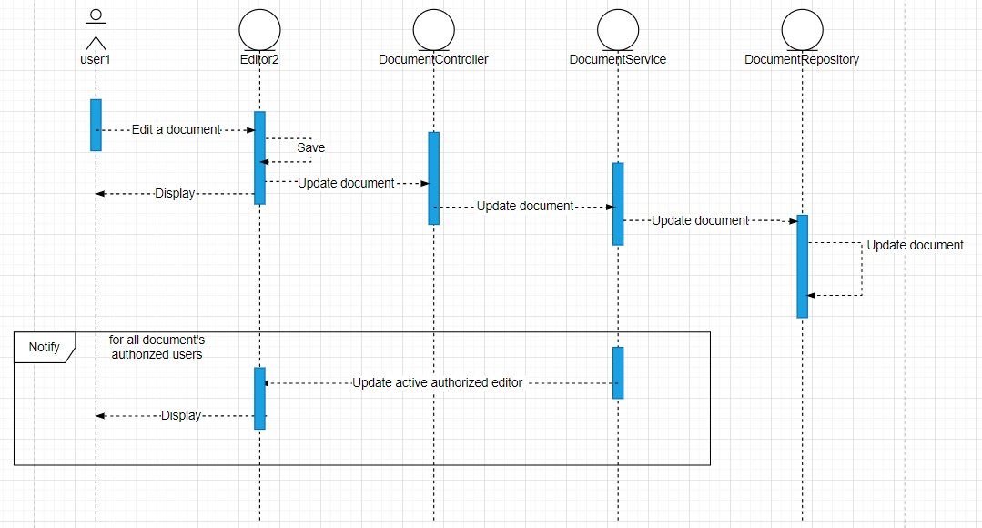

## Sketch

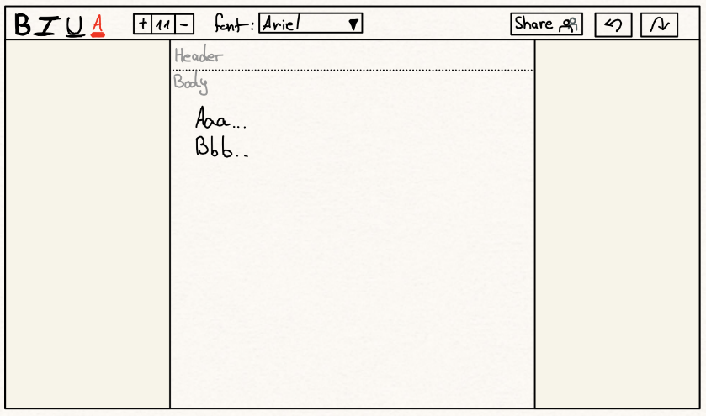

## Mock up

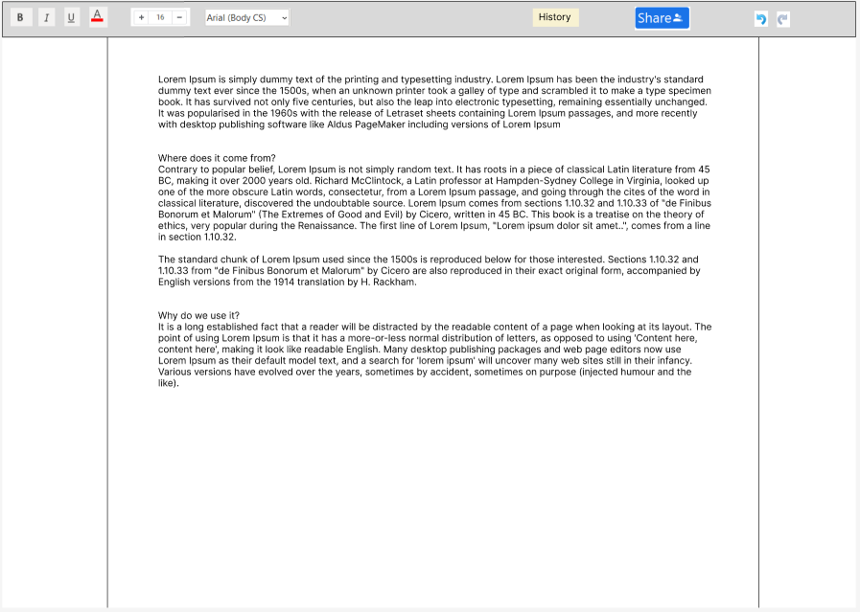

# Testing

[Test Cases - Editor](https://docs.google.com/spreadsheets/d/1psZ7J_LAcTIqg6SIw1x8O5kV-aJt-p9B0B7MfG3G9UY/edit?usp=share_link)